Hoverboard Motor - AC or DC Motor?

Articles Provided in this document

[What’s the difference between BLDC and synchronous AC motors?](https://www.motioncontroltips.com/faq-whats-the-difference-between-bldc-and-synchronous-ac-motors/)

[AC versus BLDC Motors](https://www.pfonline.com/articles/ac-versus-bldc-motors)

[Brushless DC Motor vs. AC Motor vs. Brushed Motor?](https://www.orientalmotor.com/brushless-dc-motors-gear-motors/technology/AC-brushless-brushed-motors.html)

[Electric Hoverboard Monorover R2 Teardown](https://beta.ivc.no/wiki/index.php/Electric_Hoverboard_Monorover_R2_Teardown)

[DC Hoverboard Motors on Alibaba](https://www.alibaba.com/showroom/wheel-hoverboard-dc-motor.html)

[Brushless DC Motor](https://www.allaboutcircuits.com/textbook/alternating-current/chpt-13/brushless-dc-motor/)

# **What’s the difference between BLDC and synchronous AC motors?**

# DECEMBER 17, 2015 BY [DANIELLE COLLINS](https://www.motioncontroltips.com/author/dcollins2/) [LEAVE A COMMENT](https://www.motioncontroltips.com/faq-whats-the-difference-between-bldc-and-synchronous-ac-motors/#respond)

# [Facebook](https://www.motioncontroltips.com/#facebook)

# [Twitter](https://www.motioncontroltips.com/#twitter)

# [LinkedIn](https://www.motioncontroltips.com/#linkedin)

# [Share](https://www.addtoany.com/share#url=https%3A%2F%2Fwww.motioncontroltips.com%2Ffaq-whats-the-difference-between-bldc-and-synchronous-ac-motors%2F&title=What%E2%80%99s%20the%20difference%20between%20BLDC%20and%20synchronous%20AC%20motors%3F)

# The short answer is: brushless DC (BLDC) and synchronous AC motors are similar in construction and operation. Some manufacturers and experts even group them together as similar technologies, in the category of “permanent magnet synchronous motors.” Their key difference, however, lies in the stator coil windings and resulting back-EMF waveform of each motor. This gives them distinct performance characteristics and dictates separate drive techniques for each.

#### **Similarities in construction**

# Despite the specificities of their names, BLDC and synchronous AC motors are both brushless, and both run at synchronous speeds. Brushless means that they rely on electronics (typically Hall-effect sensors), rather than mechanical brushes, to control current to the windings. And synchronous means that their rotor and stator magnetic fields rotate at the same frequency, or with synchronous speed

# Both BLDC and synchronous AC motors have permanent magnets (typically four or more) mounted to the rotor. The rotor magnets can be either ferrite, which are less expensive but have a relatively low flux density, or rare earth alloy (such as Neodymium), which have a higher flux density but are cost-prohibitive for some applications. The stator is made of steel laminations, with windings (typically three) placed in slots cut axially in the laminations.

# BLDC and synchronous AC motors

# **Three-phase synchronous motor with a single permanent magnet rotor.**

# ***Image credit: Texas Instruments Incorporated***

# The rotor permanent magnets create a rotor flux, and current supplied to the stator windings creates electromagnetic poles. When the rotor position is such that a N pole of the rotor is near a N pole of the stator, the poles repel each other and torque is produced.

#### **Differences in operation and performance**

# **BLDC and synchronous AC motors**

# **Back-EMF (Vc) is a voltage generated by the rotation of the motor. It opposes the applied voltage (Va) and reduces the current flowing through the coils.**

# ***Image credit: Dr. J. R. White, profjrwhite.com***

# In BLDC motors, the stator coils are wound trapezoidally, and the back-EMF produced has a trapezoidal wave form. Because of their trapezoidal waveform, direct current is required in order to get the best performance form BLDC motors. In contrast, synchronous AC motors are wound sinusoidally and produce a sinusoidal back-EMF, so they require sinusoidal drive current in order to achieve the best performance.

# The type of drive current also has an effect on the amount of noise that the motor produces. The trapezoidal drive current used by BLDC motors tends to produce a greater amount of audible and electrical noise in comparison to sinusoidally driven synchronous AC motors.

# 

# BLDC and synchronous AC motors

# **Sinusoidal (left) and trapezoidal (right) current waveforms for synchronous AC and BLDC motors, respectively.**

# ***Image credit: STMicroelectronics***

# Commutation, which is the act of switching the motor phase currents to drive the appropriate stator coil, is determined by the rotor position. In BLDC motors, the rotor position is typically monitored by three Hall-effect sensors and commutation is achieved in six steps, or every 60 electrical degrees. Because the commutation is not continuous, a torque ripple is produced at each phase commutation (every 60 degrees).

# Synchronous AC motors benefit from continuous monitoring of the rotor position via a single Hall-effect sensor or a rotary encoder, in conjunction with control logic. Because their commutation is continuous, synchronous AC motors are able to operate without the torque ripple found in BLDC motors. Sinusoidal commutation, however, requires more complex control algorithms than trapezoidal commutation.

# While their construction is virtually identical, the difference in drive current and back-EMF between BLDC and synchronous AC motors is a significant distinction. Applying the appropriate drive current and control is an important factor in their operation and performance.

# FILED UNDER: [DC MOTORS](https://www.motioncontroltips.com/category/motors/dc-motors/), [FAQS + BASICS](https://www.motioncontroltips.com/category/basics-and-faqs/), [MOTORS](https://www.motioncontroltips.com/category/motors/), [SERVO MOTORS](https://www.motioncontroltips.com/category/motors/servo-motors/), [STEPPER MOTORS](https://www.motioncontroltips.com/category/motors/stepper-motors/)

# TAGGED WITH: [BLDC MOTOR](https://www.motioncontroltips.com/tag/bldc-motor/), [BRUSHLESS MOTOR](https://www.motioncontroltips.com/tag/brushless-motor/), [PERMANENT MAGNET MOTOR](https://www.motioncontroltips.com/tag/permanent-magnet-motor/), [SYNCHRONOUS MOTOR](https://www.motioncontroltips.com/tag/synchronous-motor/)

# [**Brushless DC Motor**](https://www.orientalmotor.com/brushless-dc-motors-gear-motors/index.html) **vs. AC Motor vs. Brushed Motor?**

Brushless DC motors provide high power in a small package. Oriental Motor manufacturers a wide range of AC motor and brushless DC (BLDC) motor products. So why choose one technology over the other? There are several key differences between the different technologies.

## **Motor Construction**

Brushed DC motors depend on a mechanical system to transfer current, while AC and brushless DC gear motors use an electronic mechanism to control current. The brushed motors have a wound armature attached to the center with a permanent magnet bonded to a steel ring surrounding the rotor. As the brushes come into contact with the commutator the current passes through to the armature coils.

AC induction motors and BLDC motors do not depend upon the mechanical system (brushes) to control current. The AC and BLDC motors pass current through the stator (electromagnet) which is connected to AC power directly or via a solid-state circuit.

In AC induction motors the rotor turns in response to the "induction" of a rotating magnetic field within the stator, as the current passes. Rather than inducing the rotor in a brushless DC motor, permanent magnets are bonded directly to the rotor, as the current passes through the stator, the poles on the rotor rotate in relation to the electromagnetic poles created within the stator, creating motion.

| **Brushed Motor Construction** | **AC Motor Construction** | **Brushless Motor Construction** |
| --- | --- | --- |
| Brushed Motor Construction | AC Motor Construction | Brushless Motor Construction |

## **Efficiency**

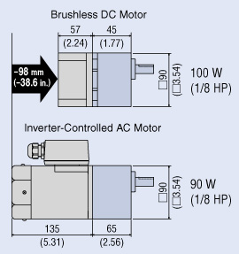

The efficiency of a system is defined as the amount of output received, as a percentage of what was input into the system. Therefore, when we talk about the energy efficiency of brushless DC (BLDC) motors, we are saying that we can obtain a relatively high amount of mechanical power, in return for the electrical power that we use.

All three technologies have power loss in the form of I-R losses. DC motors utilize permanent magnets so none of their energy needs to be used in the creation of an electromagnet as in AC motors. The energy used by AC motors to create the electromagnet decreases the efficiency of the AC motor in comparison to the DC motors.

At the same time, BLDC motors are considered more energy efficient than brushed DC-motors. This means for the same input power, a BLDC motor will convert more electrical power into mechanical power than a brushed motor, mostly due to absence of friction of brushes. The enhanced efficiency is greatest in the no-load and low-load region of the motor's performance curve.

A BLDC motor, for the same mechanical work output, will usually be smaller than a brushed DC motor, and always smaller than an AC induction motor. The BLDC motor is smaller because its body has less heat to dissipate. From that standpoint, BLDC motors use less raw material to build, and are better for the environment.

## **Service and Maintenance: DC vs. BLDC**

Brushed motors are not only larger than their brushless counterparts, they also have a shorter service life. The brushes in the brushed motor are usually made of carbon or graphite compounds which wear during use. These brushes will require maintenance and replacement over time, so the motor will need to be accessible to ensure continued service. As the brushes wear the not create dust but noise caused by the rubbing against the commutator. Brushless motors have longer service lives and are cleaner and quieter because they do not have parts the rub or wear during use.

| **Brushed DC Motor** | **Brushless DC Motor** |
| --- | --- |
| Brushed Motor Structure | Brushless DC Motor Structure |

## **Speed Stability**

Hall-effect sensors built in the BLDC motor detect the change in polarity from an N pole to an S pole as the rotor is spinning. Based on the time between state changes, the rotor's speed is determined. This information is then fed to the drive circuit to adjust the speed of the switching sequence.

## **High Speed Operation**

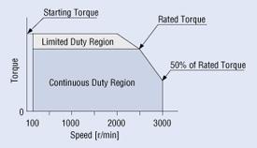

Brushed and brushless DC systems provide flat torque over a wide speed range while AC motors often lose torque as speed increases. Oriental Motor has several BLDC packages offering speed control ranges as low as 3 rpm to as high as 4,000 rpm.

## **Want to learn more?**

ORIENTAL MOTOR's Technical Support Team and Application Engineers will work with you to determine the best solution for your application. ORIENTAL MOTOR's experienced team members know the technology inside and out. We'll find the right solution based on your needs and explain the alternatives. Call 1-800-GO-VEXTA (468-3982) to speak with an ORIENTAL MOTOR Technical Support Team Member.

Brushless DC Motor & Drivers

[**Brushless DC Motors & Drivers**](https://www.orientalmotor.com/brushless-dc-motors-gear-motors/index.html)

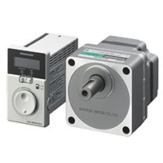

[**Quick View**](https://www.orientalmotor.com/brushless-dc-motors-gear-motors/technology/AC-brushless-brushed-motors.html#)

Three-Phase AC Motors

[**Three-Phase AC Motors**](https://www.orientalmotor.com/ac-motors-gear-motors/three-phase-ac-gear-motors.html)

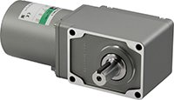

[**Quick View**](https://www.orientalmotor.com/brushless-dc-motors-gear-motors/technology/AC-brushless-brushed-motors.html#)

# Brushless DC Motor

#### Chapter 13 - AC Motors

Brushless DC motors were developed from conventional brushed DC motors with the availability of [solid-state power semiconductors](https://www.allaboutcircuits.com/textbook/semiconductors/chpt-7/hysteresis/). So, why do we discuss brushless DC motors in a chapter on AC motors? Brushless DC motors are similar to AC synchronous motors. The major difference is that synchronous motors develop a sinusoidal back *EMF*, as compared to a rectangular, or trapezoidal, back EMF for brushless DC motors. Both have stator created rotating magnetic fields producing torque in a magnetic rotor.

Synchronous motors are usually large multi-kilowatt size, often with electromagnet rotors. True synchronous motors are considered to be single speed, a submultiple of the powerline frequency. Brushless DC motors tend to be small– a few watts to tens of watts, with permanent magnet rotors. The speed of a brushless DC motor is not fixed unless driven by a phased locked loop slaved to a reference frequency. The style of construction is either cylindrical or pancake.

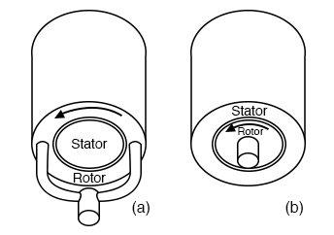*Cylindrical construction: (a) outside rotor, (b) inside rotor*

The most usual construction, cylindrical, can take on two forms (figure above). The most common cylindrical style is with the rotor on the inside, above right. This style of motor is used in hard disk drives. It is also possible to put the rotor on the outside surrounding the stator. Such is the case with brushless DC fan motors, without the shaft. This style of construction may be short and stout. However, the direction of the magnetic flux is radial with respect to the rotational axis.

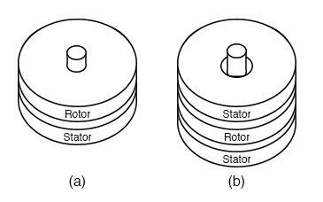*Pancake motor construction: (a) single stator, (b) double stator*

High torque pancake motors may have stator coils on both sides of the rotor (figure above-b).

Lower torque applications like floppy disk drive motors suffice with a stator coil on one side of the rotor, (Figure above-a). The direction of the magnetic flux is axial, that is, parallel to the axis of rotation.

The commutation function may be performed by various shaft position sensors: optical encoder, a magnetic encoder (resolver, synchro, etc), or Hall effect magnetic sensors. Small inexpensive motors use Hall effect sensors. A Hall effect sensor is a semiconductor device where the electron flow is affected by a magnetic field perpendicular to the direction of current flow. It looks like a four-terminal variable resistor network. The voltages at the two outputs are complementary. Application of a magnetic field to the sensor causes a small voltage change at the output. The Hall output may drive a [comparator](https://www.allaboutcircuits.com/textbook/experiments/chpt-6/voltage-comparator/) to provide for the more stable drive to the power device. Or, it may drive a compound [transistor](https://www.allaboutcircuits.com/textbook/semiconductors/chpt-4/bipolar-junction-transistors-bjt/) stage if properly biased. More modern Hall effect sensors may contain an integrated amplifier and digital circuitry. This 3-lead device may directly drive the power transistor feeding a phase winding. The sensor must be mounted close to the permanent magnet rotor to sense its position.

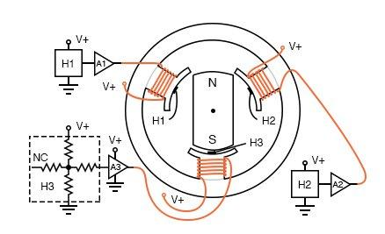*Hall effect sensors commutate 3-φ brushless DC motor*

The simple cylindrical 3-φ motor (figure above) is commutated by a Hall effect device for each of the three stator phases. The changing position of the permanent magnet rotor is sensed by the Hall device as the polarity of the passing rotor pole changes. This Hall signal is amplified so that the stator coils are driven with the proper current. Not shown here, the Hall signals may be processed by combinatorial logic for more efficient drive waveforms.

The above cylindrical motor could drive a hard drive if it were equipped with a phased locked loop (PLL) to maintain a constant speed. Similar circuitry could drive the pancake floppy disk drive motor (figure below). Again, it would need a PLL to maintain a constant speed.

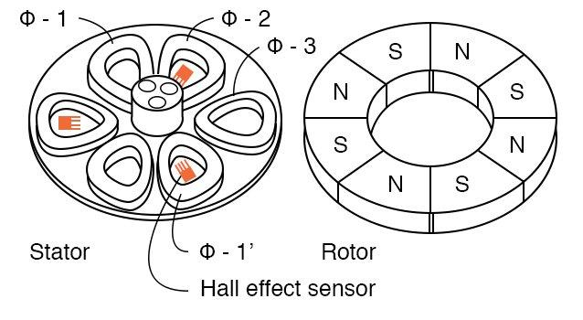*Brushless pancake motor*

The 3-φ pancake motor has 6-stator poles and 8-rotor poles. The rotor is a flat ferrite ring magnetized with eight axially magnetized alternating poles. We do not show that the rotor is capped by a mild steel plate for mounting to the bearing in the middle of the stator. The steel plate also helps complete the magnetic circuit. The stator poles are also mounted atop a steel plate, helping to close the magnetic circuit. The flat stator coils are trapezoidal to more closely fit the coils, and approximate the rotor poles. The 6-stator coils comprise three winding phases.

If the three stator phases were successively energized, a rotating magnetic field would be generated. The permanent magnet rotor would follow as in the case of a synchronous motor. A two-pole rotor would follow this field at the same rotation rate as the rotating field. However, our 8-pole rotor will rotate at a submultiple of this rate due to the extra poles in the rotor.

**The brushless DC fan motor has these features:**

**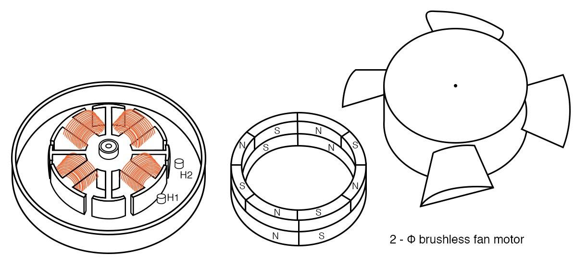***Brushless fan motor, 2-φ*

* • The stator has 2-phases distributed between 4-poles
* • There are 4-salient poles with no windings to eliminate zero torque points.
* • The rotor has four main drive poles.
* • The rotor has 8-poles superimposed to help eliminate zero torque points.
* • The Hall effect sensors are spaced at 45o physical.
* • The fan housing is placed atop the rotor, which is placed over the stator.

The goal of a brushless fan motor is to minimize the cost of manufacture. This is an incentive to move lower performance products from a 3-φ to a 2-φ configuration. Depending on how it is driven, it may be called a 4-φ motor.

You may recall that conventional DC motors cannot have an even number of armature poles (2, 4, etc.) if they are to be self-starting, 3, 5, 7 being common. Thus, it is possible for a hypothetical 4-pole motor to come to rest at a torque minima, where it cannot be started from rest. The addition of the four small salient poles with no windings superimposes a ripple torque upon the torque vs position curve. When this ripple torque is added to normal energized-torque curve, the result is that torque minima are partially removed. This makes it possible to start the motor for all possible stopping positions. The addition of eight permanent magnet poles to the normal 4-pole permanent magnet rotor superimposes a small second harmonic ripple torque upon the normal 4-pole ripple torque. This further removes the torque minima. As long as the torque minima do not drop to zero, we should be able to start the motor. The more successful we are in removing the torque minima, the easier the motor starting.

The 2-φ stator requires that the Hall sensors be spaced apart by 90**°**electrical. If the rotor was a 2-pole rotor, the Hall sensors would be placed 90**°** physical. Since we have a 4-pole permanent magnet rotor, the sensors must be placed 45**°** physical to achieve the 90**°** electrical spacing. (Note Hall spacing above.) The majority of the torque is due to the interaction of the inside stator 2-φ coils with the 4-pole section of the rotor. Moreover, the 4-pole section of the rotor must be on the bottom so that the Hall sensors will sense the proper commutation signals. The 8-poles rotor section is only for improving motor starting.

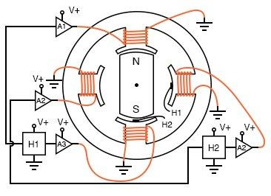*Brushless DC motor 2-φ push-pull drive*

In the figure above, the 2-φ push-pull drive (also known as 4-φ drive) uses two Hall effect sensors to drive four windings. The sensors are spaced 90**°** electrical apart, which is 90**°** physical for a single pole rotor. Since the Hall sensor has two complementary outputs, one sensor provides commutation for two opposing windings.

* [**← Previous Page**](https://www.allaboutcircuits.com/textbook/alternating-current/chpt-13/stepper-motors/)
* [**Textbook Index**](https://www.allaboutcircuits.com/textbook/)
* [**Next Page →**](https://www.allaboutcircuits.com/textbook/alternating-current/chpt-13/tesla-polyphase-induction-motors/)

This Hoverboard Motor is listed as a Brushless DC Motor (see page 4)

# Electric Hoverboard Monorover R2 Teardown

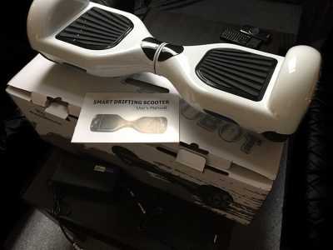

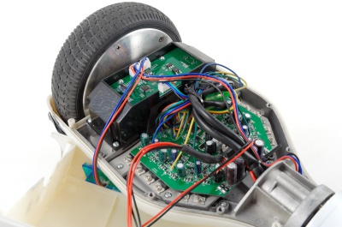

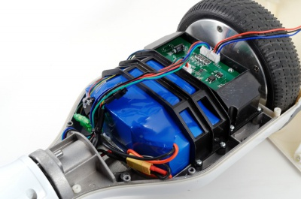

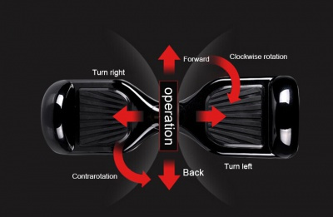

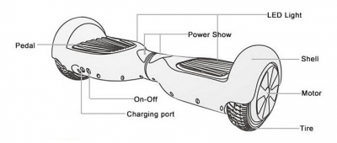

The Monorover R2 is an electric self balancing hoverboard - based on two individual motors joint at a central axis-point. It is an efficient way to get around your neighborhood, park, to the shop, in the mall and other relatively flat surface areas.

* Purchased from [Wuxi Oriental Star Metal Science And Technology Co., Ltd.](http://www.aliexpress.com/item/New-Pattern-Mobility-Scooter-Swing-Car-Two-Wheel-Scooter-Self-Balancing-Electric-Vehicle-Motorcycle-Light-and/32328839149.html) at 158.00USD and 169.46USD shipping cost, plus approx. 82.00USD in duties.
* [Hoverboard White Manual - PDF](http://beta.ivc.no/hoverboard/hoverboard-white-documents.pdf)

**Contents** [hide]

* [1](https://beta.ivc.no/wiki/index.php/Electric_Hoverboard_Monorover_R2_Teardown#Usage_specifications)
* [Usage specifications](https://beta.ivc.no/wiki/index.php/Electric_Hoverboard_Monorover_R2_Teardown#Usage_specifications)
* [2](https://beta.ivc.no/wiki/index.php/Electric_Hoverboard_Monorover_R2_Teardown#Technical_specifications)
* [Technical specifications](https://beta.ivc.no/wiki/index.php/Electric_Hoverboard_Monorover_R2_Teardown#Technical_specifications)
* [3](https://beta.ivc.no/wiki/index.php/Electric_Hoverboard_Monorover_R2_Teardown#Battery)
* [Battery](https://beta.ivc.no/wiki/index.php/Electric_Hoverboard_Monorover_R2_Teardown#Battery)
  + [3.1](https://beta.ivc.no/wiki/index.php/Electric_Hoverboard_Monorover_R2_Teardown#Upgrades)
  + [Upgrades](https://beta.ivc.no/wiki/index.php/Electric_Hoverboard_Monorover_R2_Teardown#Upgrades)
  + [3.2](https://beta.ivc.no/wiki/index.php/Electric_Hoverboard_Monorover_R2_Teardown#Charger)
  + [Charger](https://beta.ivc.no/wiki/index.php/Electric_Hoverboard_Monorover_R2_Teardown#Charger)
* [4](https://beta.ivc.no/wiki/index.php/Electric_Hoverboard_Monorover_R2_Teardown#Limitations)
* [Limitations](https://beta.ivc.no/wiki/index.php/Electric_Hoverboard_Monorover_R2_Teardown#Limitations)
* [5](https://beta.ivc.no/wiki/index.php/Electric_Hoverboard_Monorover_R2_Teardown#Control_boards)
* [Control boards](https://beta.ivc.no/wiki/index.php/Electric_Hoverboard_Monorover_R2_Teardown#Control_boards)
  + [5.1](https://beta.ivc.no/wiki/index.php/Electric_Hoverboard_Monorover_R2_Teardown#Main_board)
  + [Main board](https://beta.ivc.no/wiki/index.php/Electric_Hoverboard_Monorover_R2_Teardown#Main_board)
  + [5.2](https://beta.ivc.no/wiki/index.php/Electric_Hoverboard_Monorover_R2_Teardown#Auxiliary_boards)
  + [Auxiliary boards](https://beta.ivc.no/wiki/index.php/Electric_Hoverboard_Monorover_R2_Teardown#Auxiliary_boards)
* [6](https://beta.ivc.no/wiki/index.php/Electric_Hoverboard_Monorover_R2_Teardown#LED_status_indicators)
* [LED status indicators](https://beta.ivc.no/wiki/index.php/Electric_Hoverboard_Monorover_R2_Teardown#LED_status_indicators)
* [7](https://beta.ivc.no/wiki/index.php/Electric_Hoverboard_Monorover_R2_Teardown#Calibrate_accelerometer_offsets)
* [Calibrate accelerometer offsets](https://beta.ivc.no/wiki/index.php/Electric_Hoverboard_Monorover_R2_Teardown#Calibrate_accelerometer_offsets)
* [8](https://beta.ivc.no/wiki/index.php/Electric_Hoverboard_Monorover_R2_Teardown#Pedal_platform_stub_fix)
* [Pedal platform stub fix](https://beta.ivc.no/wiki/index.php/Electric_Hoverboard_Monorover_R2_Teardown#Pedal_platform_stub_fix)
* [9](https://beta.ivc.no/wiki/index.php/Electric_Hoverboard_Monorover_R2_Teardown#Tips_and_tricks)
* [Tips and tricks](https://beta.ivc.no/wiki/index.php/Electric_Hoverboard_Monorover_R2_Teardown#Tips_and_tricks)
* [10](https://beta.ivc.no/wiki/index.php/Electric_Hoverboard_Monorover_R2_Teardown#Details)
* [Details](https://beta.ivc.no/wiki/index.php/Electric_Hoverboard_Monorover_R2_Teardown#Details)

## Usage specifications

* Road surface: relatively flat, no more than +-25mm bumps (asphalt, grass, fine gravel)
* Maximum speed: 12km/h (tested), begins to beep - 15km/h (tested) comfortably possible
* Max riding angle: approx. 15° to 20°, vary depending on rider's weight, road condition and temperature (19° tested)
* Range per charge: 20km
* Ride height: 110 mm
* Ground clearance: 30 mm
* Turning radius: 0°, on the spot
* Tire-to-chassis clearance: 5 mm
* Max load: 100kg
* Min load: 20kg, otherwise starts to oscillate
* Charge time: 2 to 3 hours using 42V 2A charger
* Modes: standby, activated, automatic shutdown after 2 minutes standby

## Technical specifications

* Released: January 2015
* Product code: DAT-N1
* Manufacturer: Shanghai DAT Electric Vehicle
* Type: self balancing hoverboard
* Main controller: STM32F103 ARM Cortex-M3 core
* Balancing controllers: 2x STM32FEB ARM Cortex-M3 core
* Balancing sensors: 2x InvenSense MPU-605 MEMS 3-axis gyroscope and 3-axis accelerometer
* **Motor: 2x direct drive 3-phase brushless DC electric wheel hub motors, 36V 350W, 700W total**
* Tire type: non-pneumatic rubber tire, road pattern
* Tire size: 7-inch / 170 mm
* Activate: switch pads for both feet
* Lights: 2x blue tinted LED windows
* Work temperature: -10°C to 40°C, peak performance at 10 to 30°C
* Environment protection: IP54 - dust protected, splashing of water
* Battery: Lithium-ion rechargeable 18650-cells, 10S2P 36V 4400mAh 158.4Wh pack with XT60 connector
* Charger: Lithium-ion charger 42V 2A 3-pin connector with built-in fan
* Internal connectors: JST Sales America B4B-XH-A(LF)(SN) 2.5mm pitch
* Dimension: 58.5 x 18.5 x 18.0 cm
* Unit weight: 10kg
* Manufacturer warranty: 1 year
* Contents: 1x Electric Hoverboard, 1x User Manual & Warranty Card, 1x Worldwide AC Power Adapter Type according to your country

8/1/2015 | 3 MINUTE READ

# AC versus BLDC Motors

Why would operators select a BLDC motor for a pump application?

An AC induction motor does not have any magnets on the rotor; instead it has a series of laminations and winding. When 3-phase power is applied to the stator of the motor, a rotating magnetic field is generated. This rotating magnetic field creates a current flow in the rotor via induction. The rotor current creates its own magnet that interacts with the stator field and generates torque.

Most AC induction motors can be run directly off of AC power with no controller, but if variable speed is required—as is the case in many pump applications—this advantage is eliminated since a VFD must be installed between the AC power and the motor.

The VFD changes the speed of the motor by altering the frequency of the power provided to the motor. For example, a motor rated at 1800 rpm and 60 Hz can be slowed down to 900 rpm by running it at 30 Hz. Even with a VFD, industrial AC induction motors have a limited speed range of about 30 to 130 percent of rated speed. They are not optimal for delivering rated torque at very low speeds, or when stalled.

Alternatively, a BLDC motor replaces the windings on the rotor with a series of permanent magnets. These magnets create a magnetic field that interacts with the stator’s field and generates torque. However, rather than simply relying on the 3-phase power to generate a rotating magnetic field, a BLDC motor requires the stator’s magnetic field to be precisely controlled and aligned with the rotor position and its fixed magnets. The stator field is controlled by a device that is all but identical to a VFD used with an AC induction motor but with one additional input; a shaft encoder attached to the rotor is required to help the motor controller keep the rotor and stator fields in proper alignment. The precise control of the stator’s magnetic field allows complete control of the motor including speed, torque and acceleration. A BLDC motor can generate full torque at zero speed. The motors are usually smaller for any given power level, and the rotor with permanent magnets is lighter than a corresponding induction rotor. Both of these traits allow a BLDC motor to respond much faster to changing load condition.

There are several advantages and features that only a BLDC can offer, including: higher efficiency, precise control of torque and speed, lower rotor inertia and smaller size.

In addition to the lower inertia and better torque control—which allow the pump to respond faster to changes in demand, precise pressure control and the ability to “dead head” the pump while maintaining pressure—a BLDC motor’s inherently fast response allows the mechanical connection to be significantly simplified.

Both types of motors require a method to convert the rotary motion of the motor to the linear reciprocating motion of a positive displacement piston pump. An AC induction motor’s relatively constant speed operation and slow dynamic response requires a complicated mechanical mechanism to accomplish this. For example, a cam or yoke arrangement may be used. Oftentimes, these devices are two to three times larger than the actual motor. They also have wear points and bearings that can easily break or wear out, and require costly maintenance or replacement.

In an AC induction motor driven pump, the AC motor, gearbox and a rather large cam drive system are all separate, but are all required to convert the rotary motion to linear motion. The cam drive system has a multiple parts, which all experience constant wear.

In comparison, a paint circulation pump system may use a small BLDC, a two-stage gear reduction and a simple rack and pinion drive system to convert the rotary motion to linear motion.

To create the reciprocating action, the direction of rotation BLDC motor is simply reversed. With lower inertia and precise torque control, the BLDC motor makes this simple and efficient. In addition to pumps, this type of solution is common in other automation equipment such as ultra-precise high speed CNC machining equipment.

*Originally published in the August 2015 issue.*

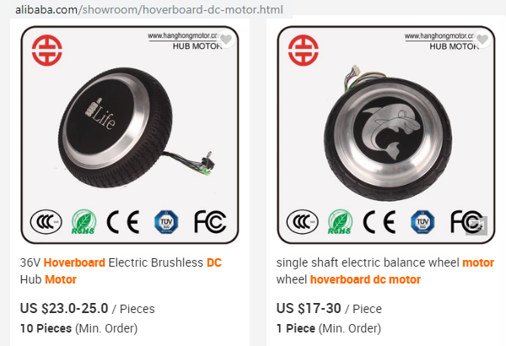

<https://www.alibaba.com/showroom/wheel-hoverboard-dc-motor.html>